1. Install nginx and run nginx on port number 81.

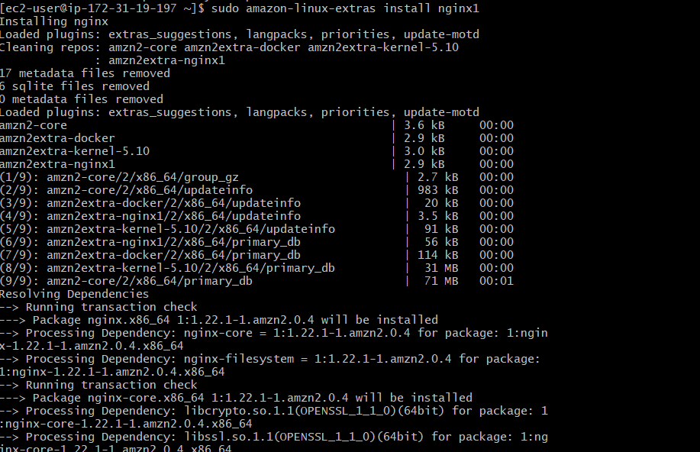

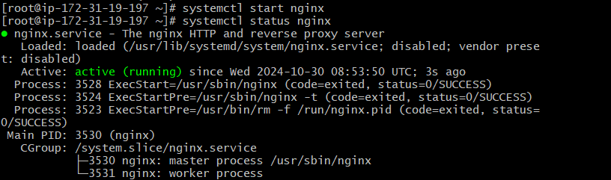



cat /etc/nginx/nginx.conf

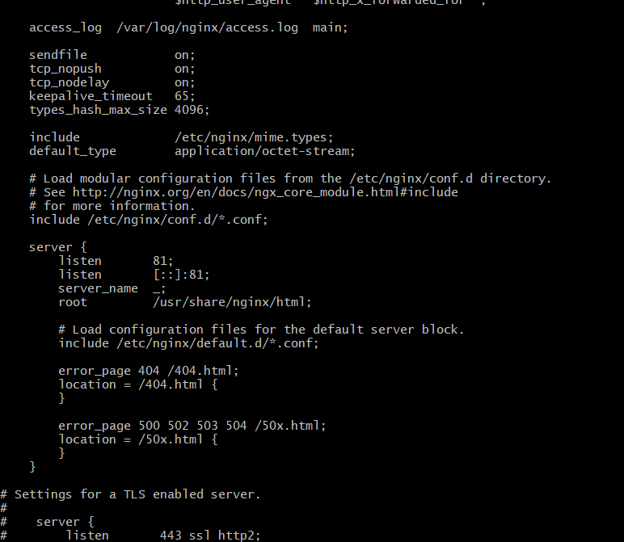



1. Deploy a sample index.html file on nginx.





1. Install Apache and run Apache on port number 82

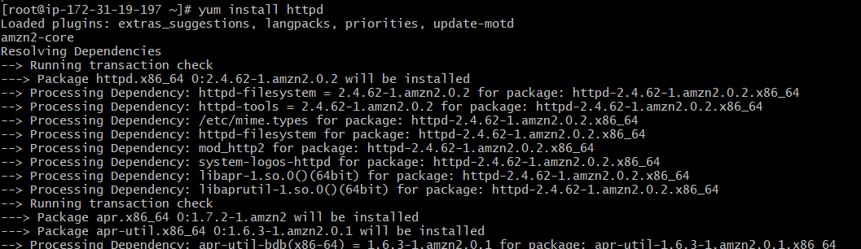



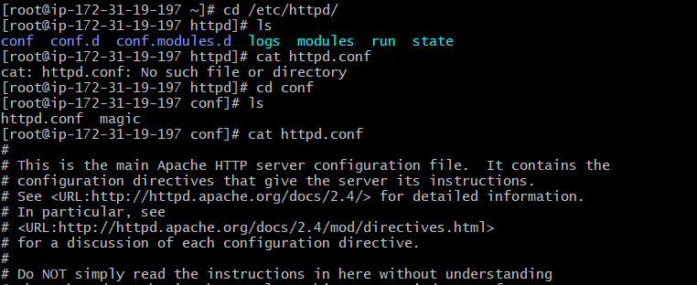

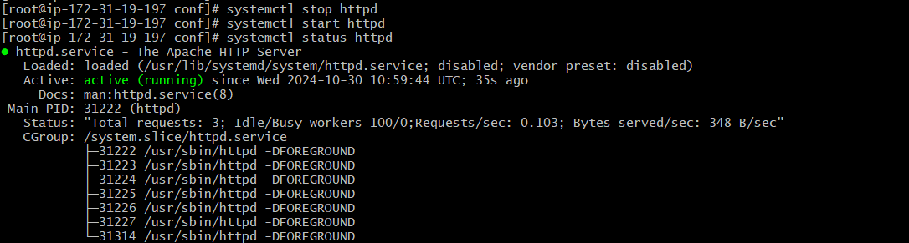



1. Deploy a sample index.html file on Apache.



Then add file and html content in index.html in location





1. Install Apache tomcat on port number 8082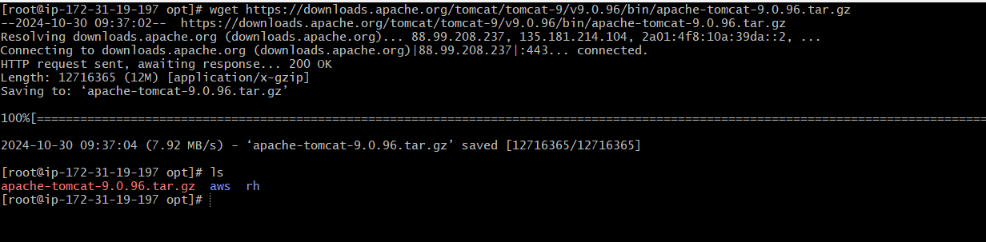

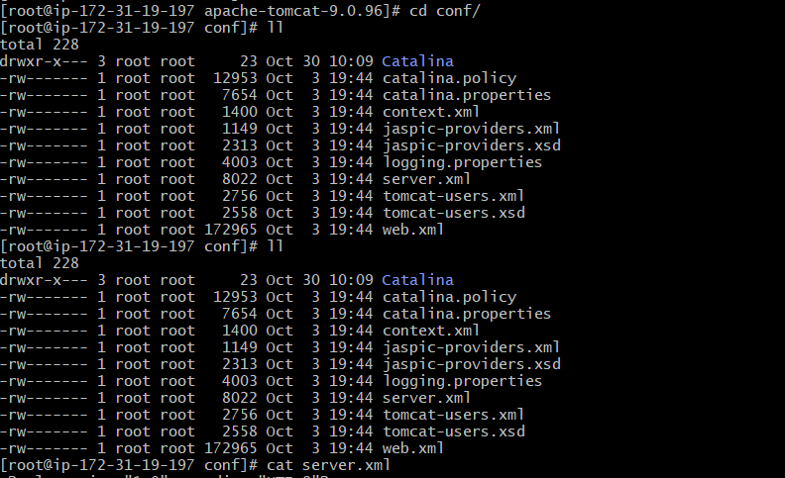

Edit port in server.xml



sudo yum install java-1.8.0-openjdk -y to install java

Change port number to 8082 then

This bin is not from root it is from

[root@ip-172-31-19-197 apache-tomcat-9.0.96]# cd bin/

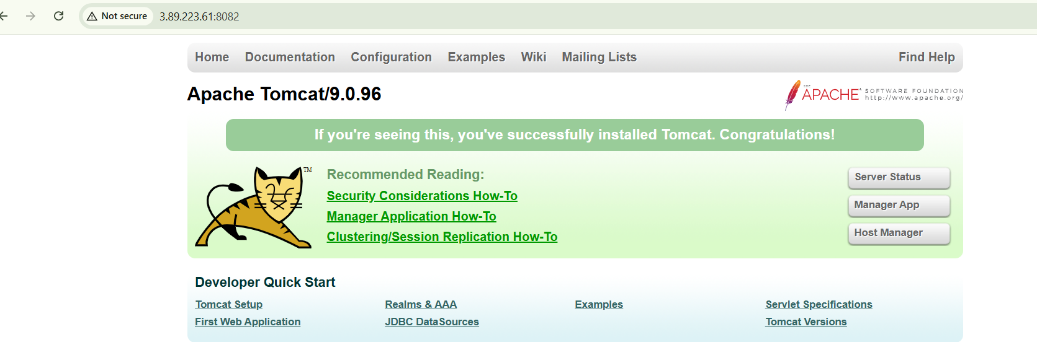

1. Deploy a sample app on webapps



Then add file and html content in index.html in location





7) Create a tomcat.service file for tomcat.

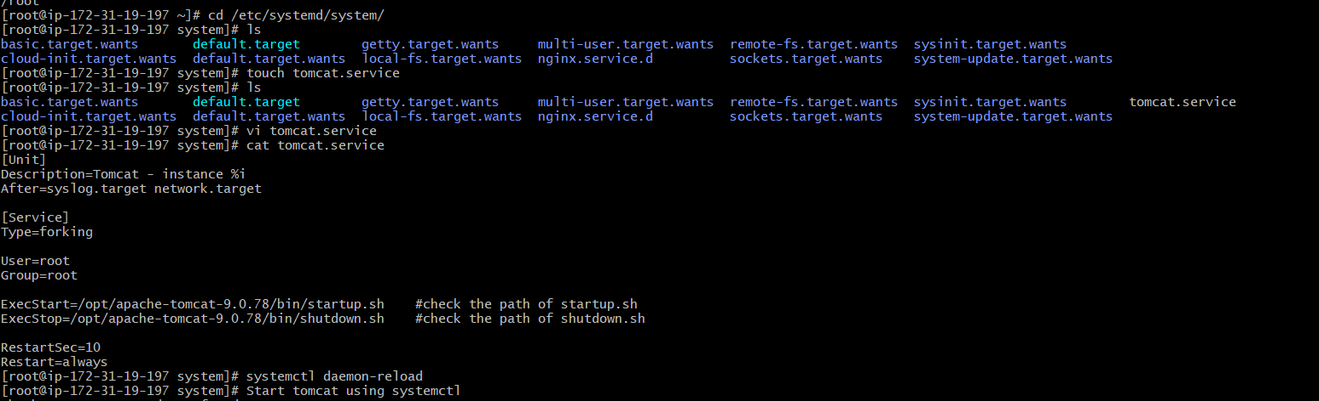

Changed here apache tomcat version then it works

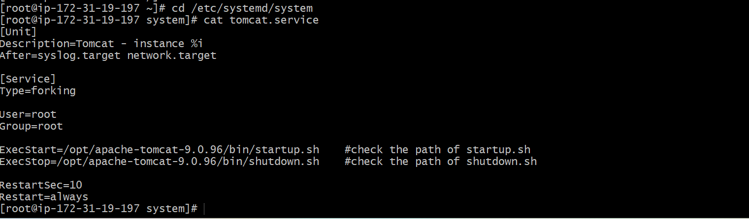

Start and stop using tomcat.service file

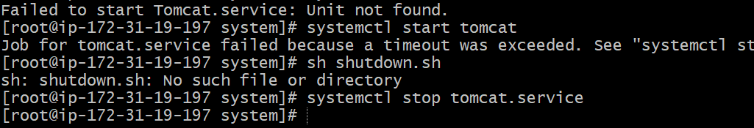



8) Configure HA Proxy server

# Stepds to do **Configure HA Proxy Server:**

**Launch 3 ec2 instances name as Server1, Server-2, HA-Proxy-Server.**

Server-1 Steps:

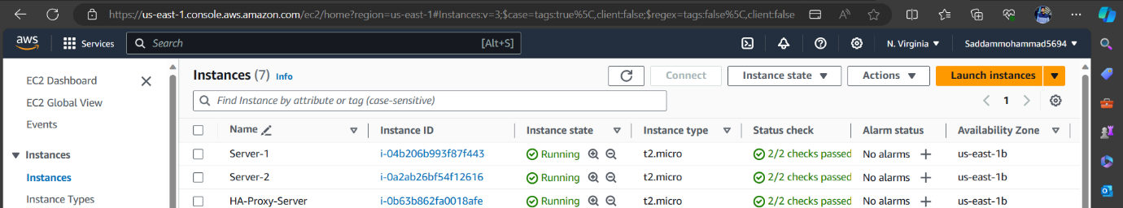

Run following command to Access the Server-1

* ssh -i your-key.pem ec2-user@Pubipaddress of Server-1 instance

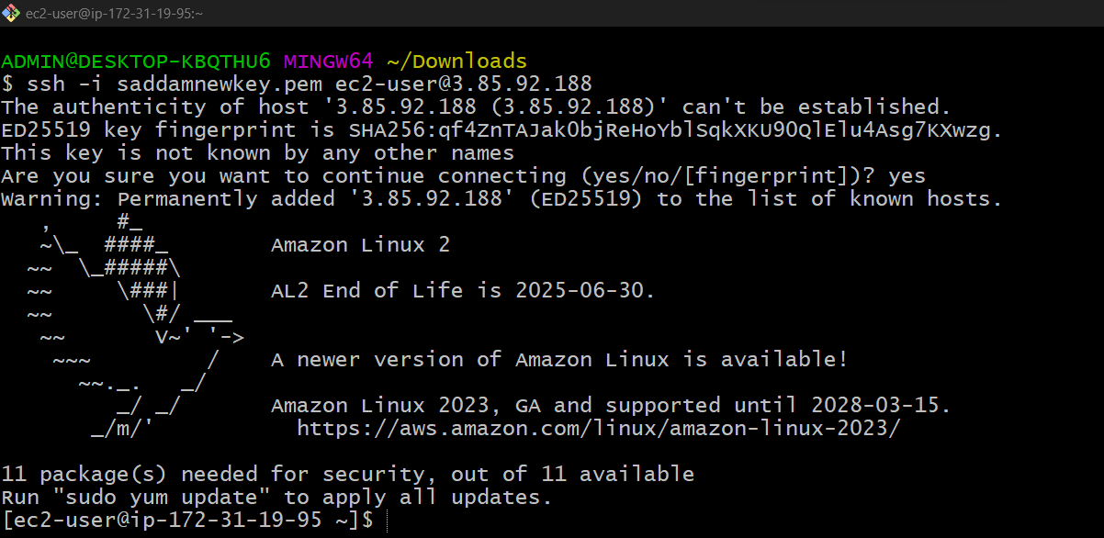

* sudo -i

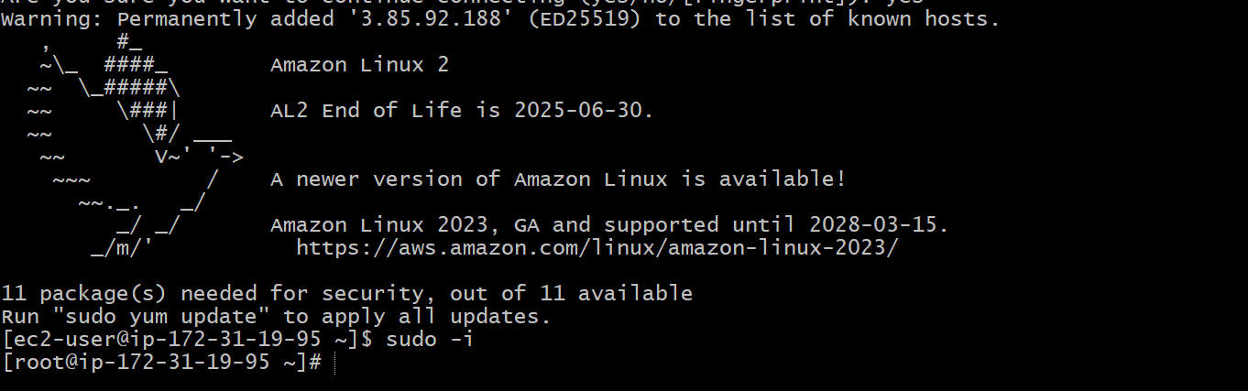

* yum update -y

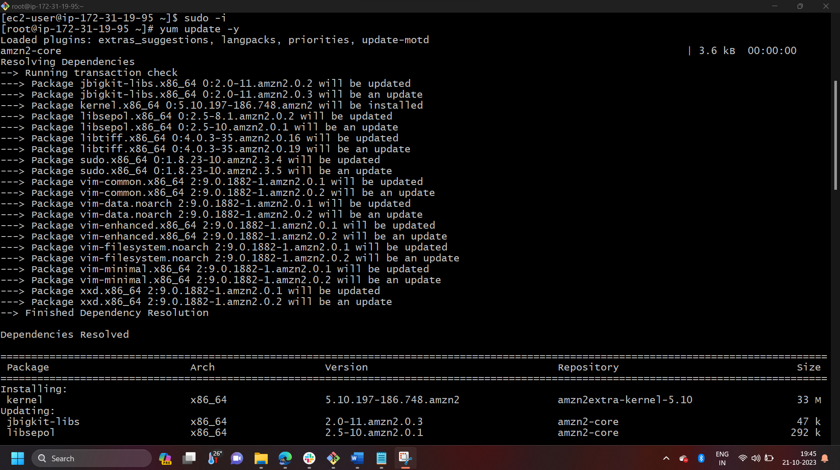 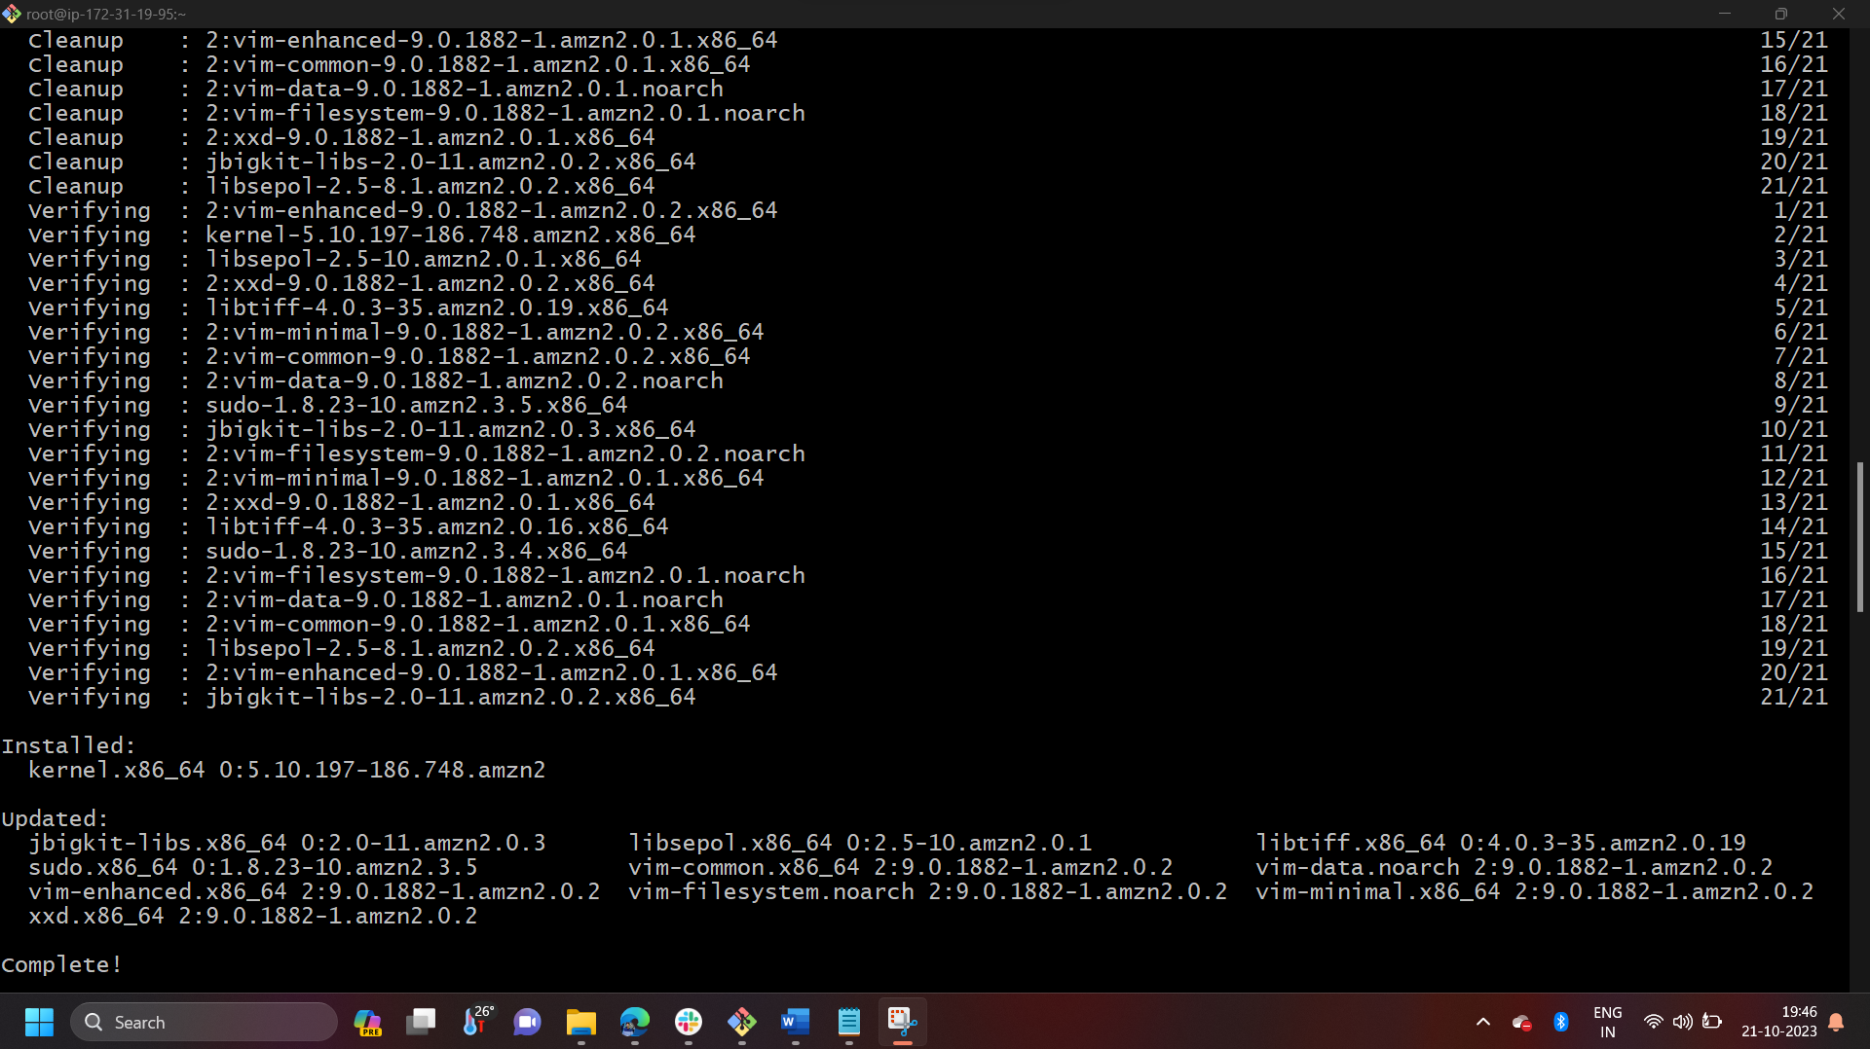

* Yum install httpd -y

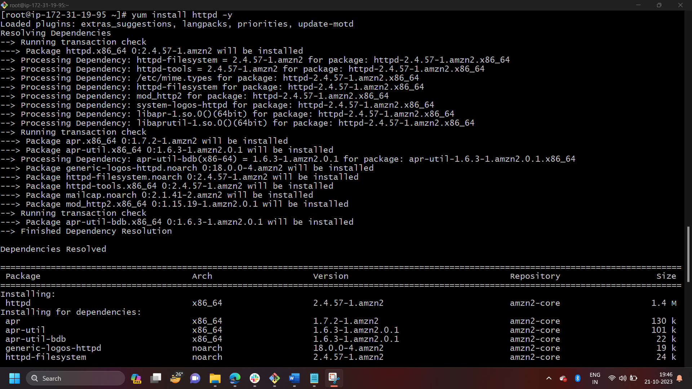 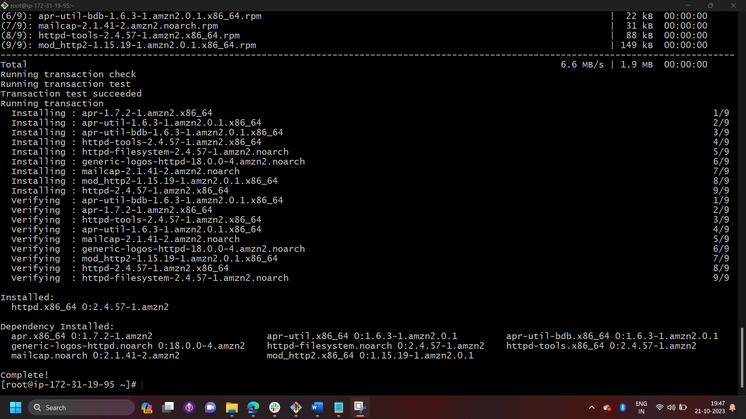

* Vi /etc/hosts
* Add HA-Proxy-Server Pubic IP Address





Run below command on Server-1  
ping load_balancer -c 4  
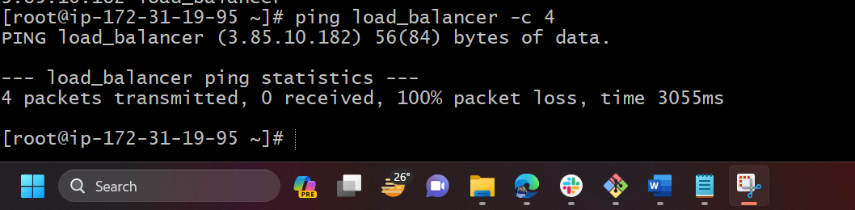

* systemctl start httpd
* systemctl status httpd

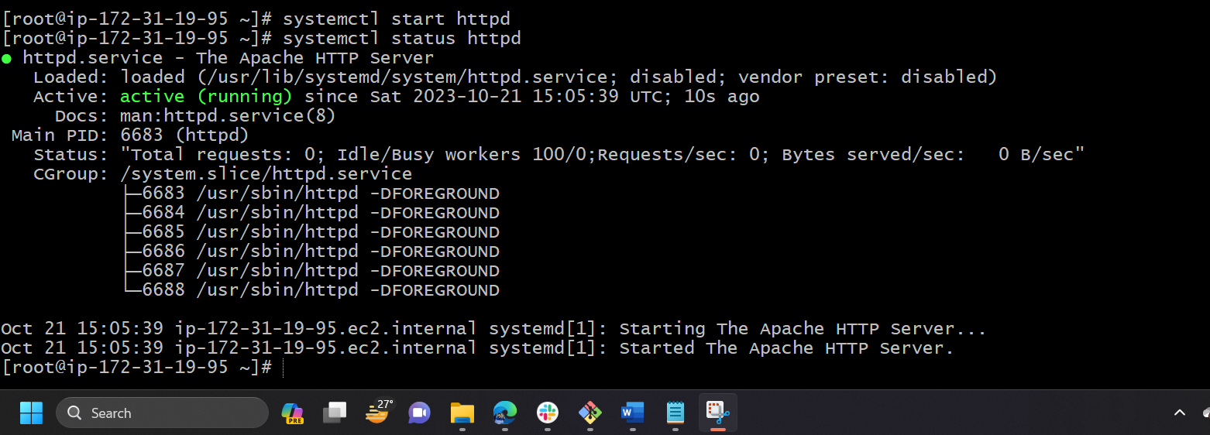

Browse with Server-1 Public IP address:80 it will work



Server-2 Steps:

Run following command to Access Server-2

* ssh -i your-key.pem ec2-user@Pubipaddress of Server-2 instance

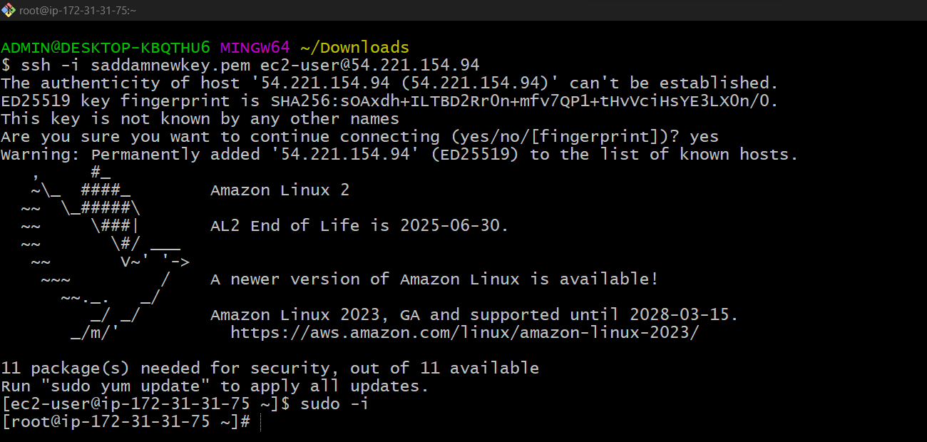

* sudo -i

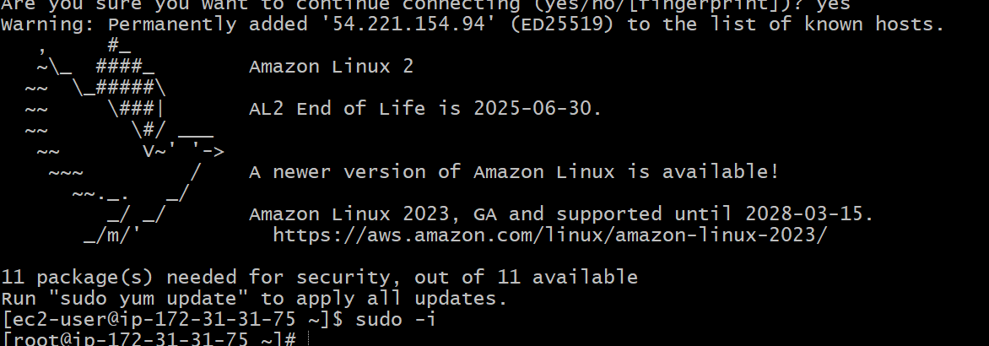

* yum update -y

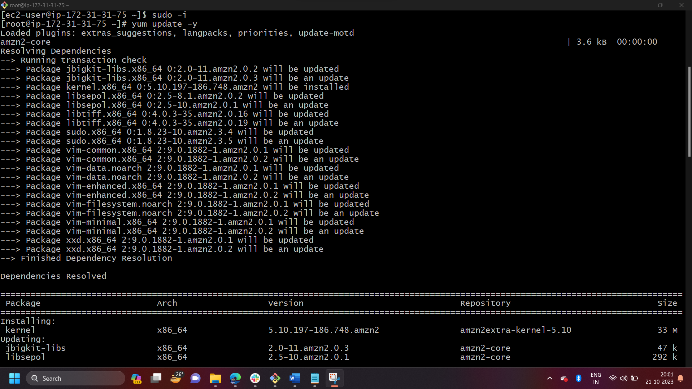 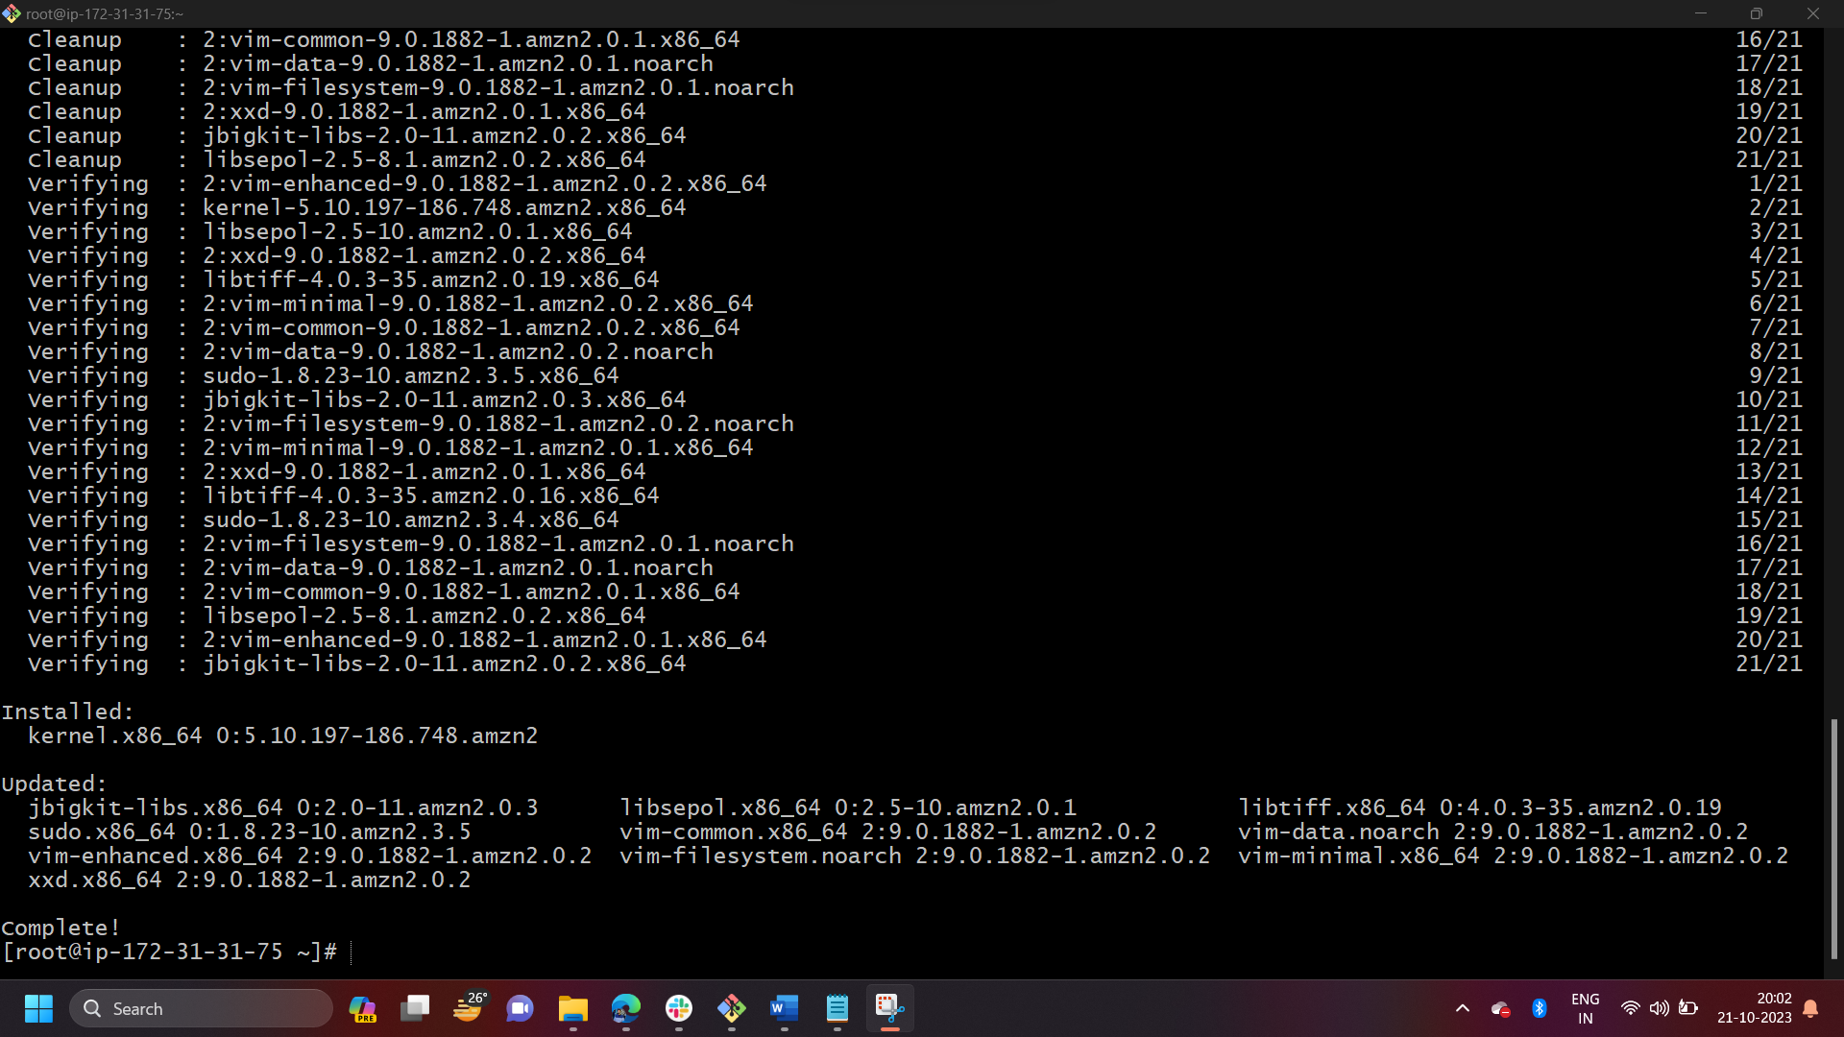

* yum install nginx -y
* sudo amazon-linux-extras install nginx1 -y

 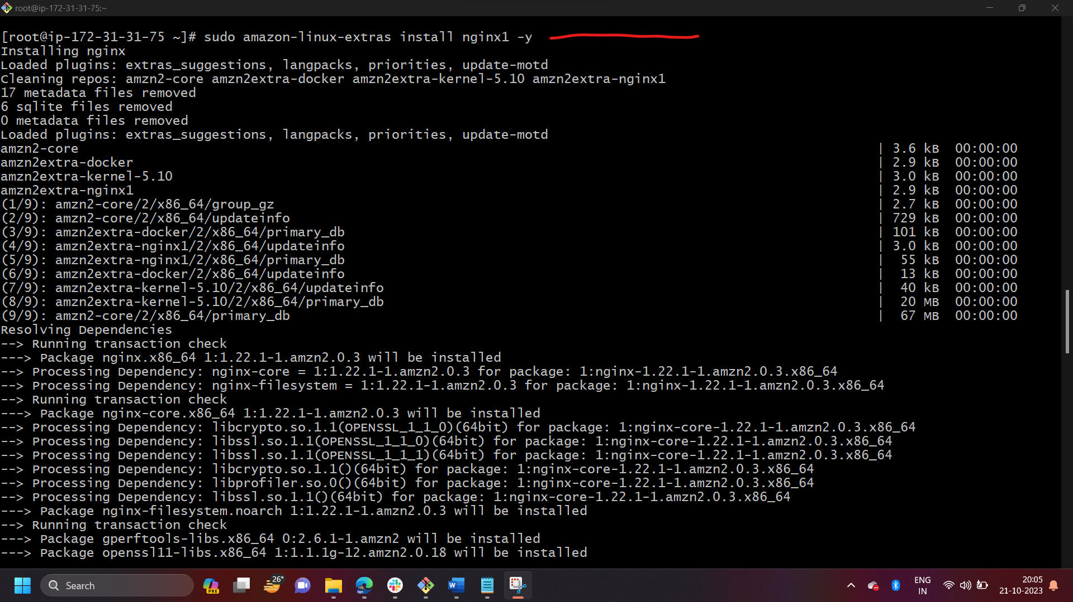

* vi /etc/hosts
* Add HA-Proxy-Server Pubic IP Address





Run below command on Server-2  
ping load_balancer -c 4

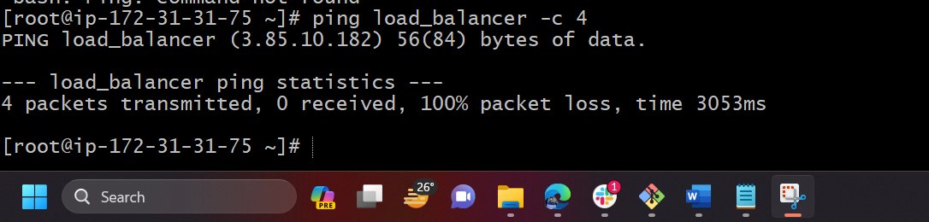

* systemctl start nginx
* systemctl status nginx

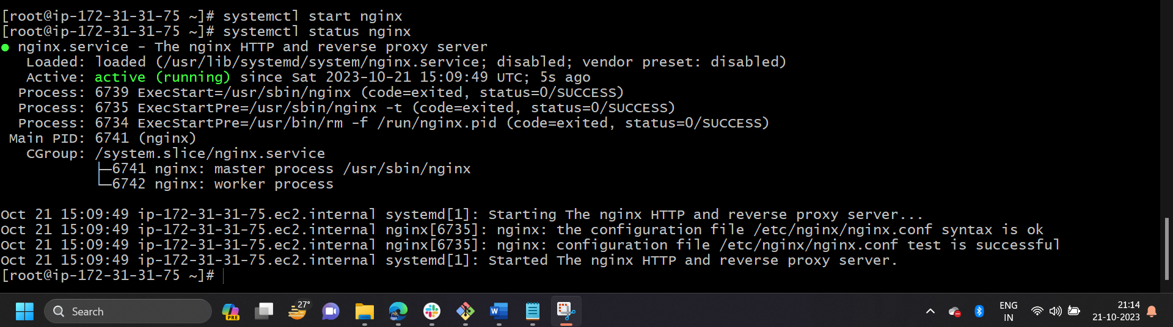

Browse with Server-2 Public IP address:80 it will work

HA-Proxy-Server Steps:

Run following command to Access HA-Proy-Server

* ssh -i your-key.pem ec2-user@Pubipaddress of HA-Proxy-Server instance

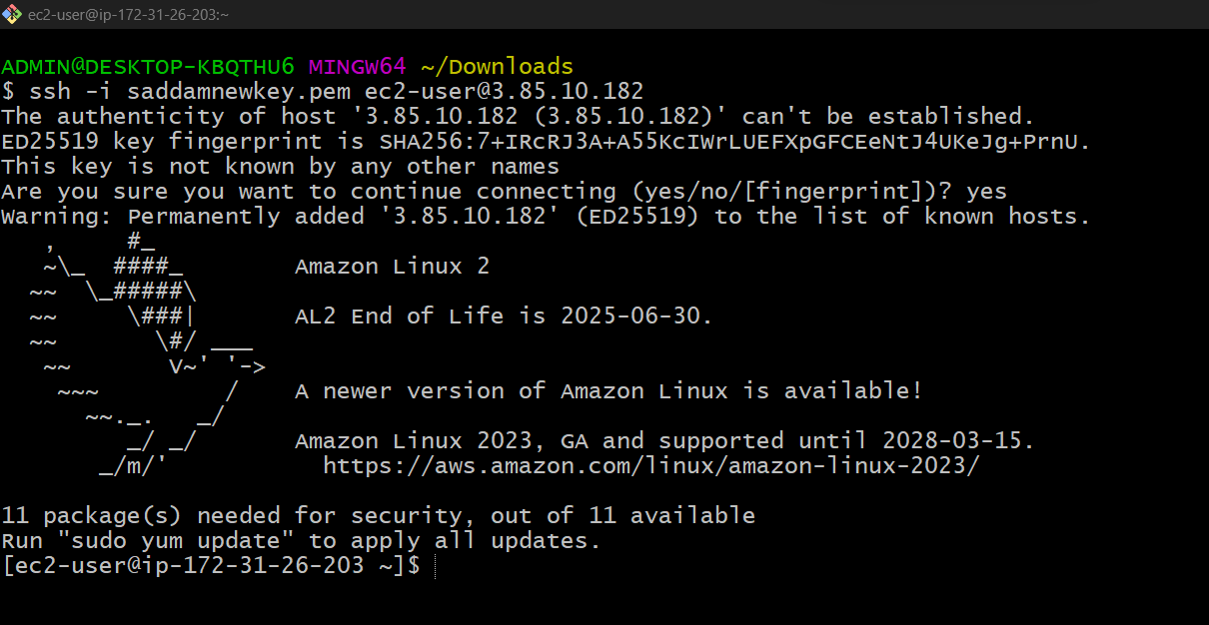

* sudo -i

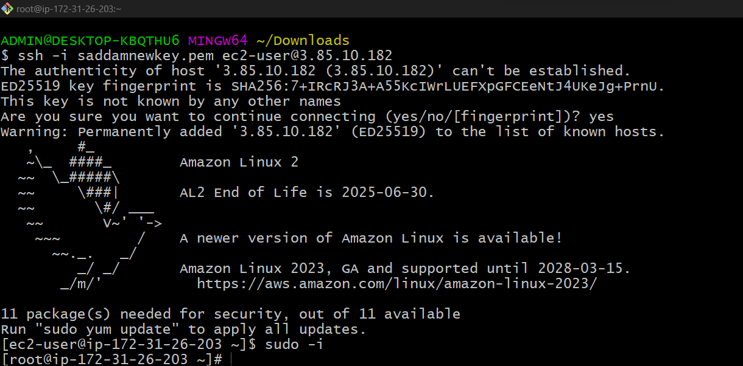

* yum update -y

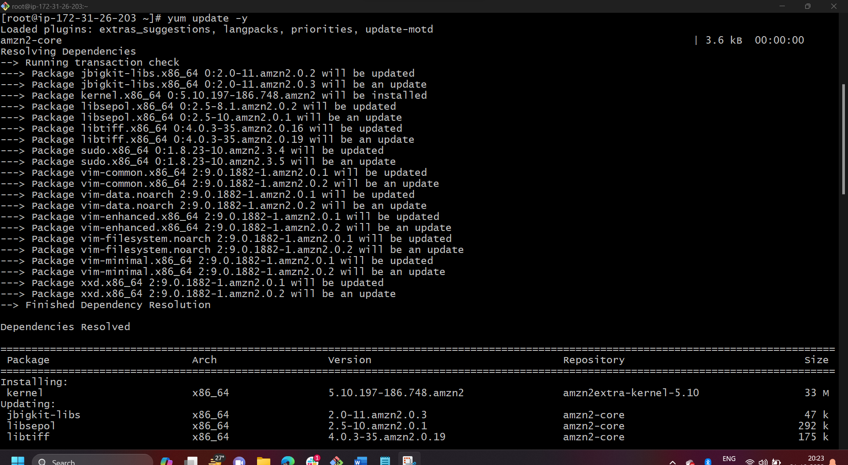

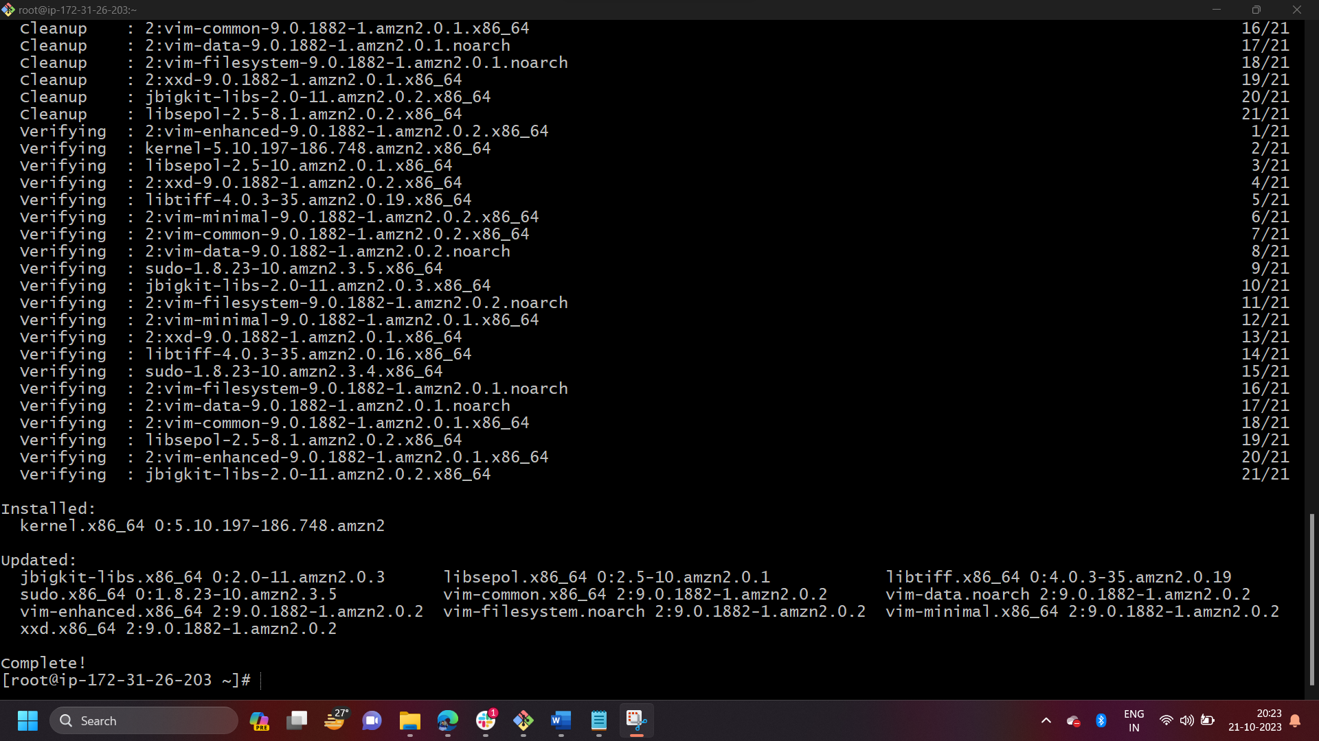

* yum install haproxy -y

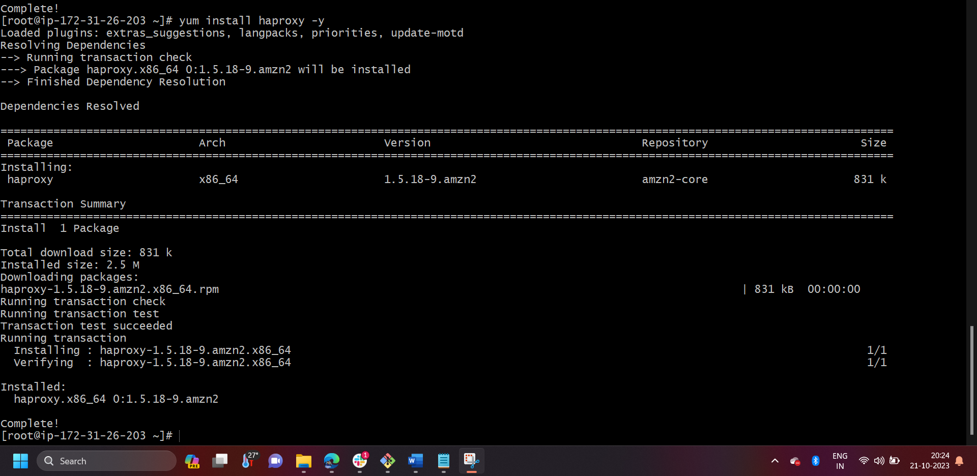

* vi /etc/hosts
* Add Server-1, Server-2 Public IP’s

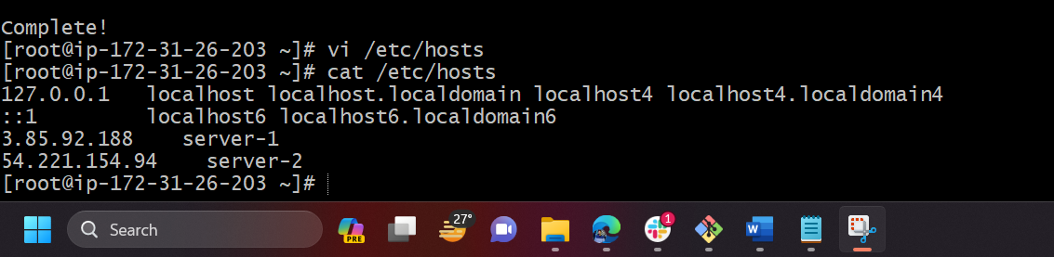



* vi /etc/haproxy/haproxy.cfg
* Add Server-1, Server-2 public IP’s

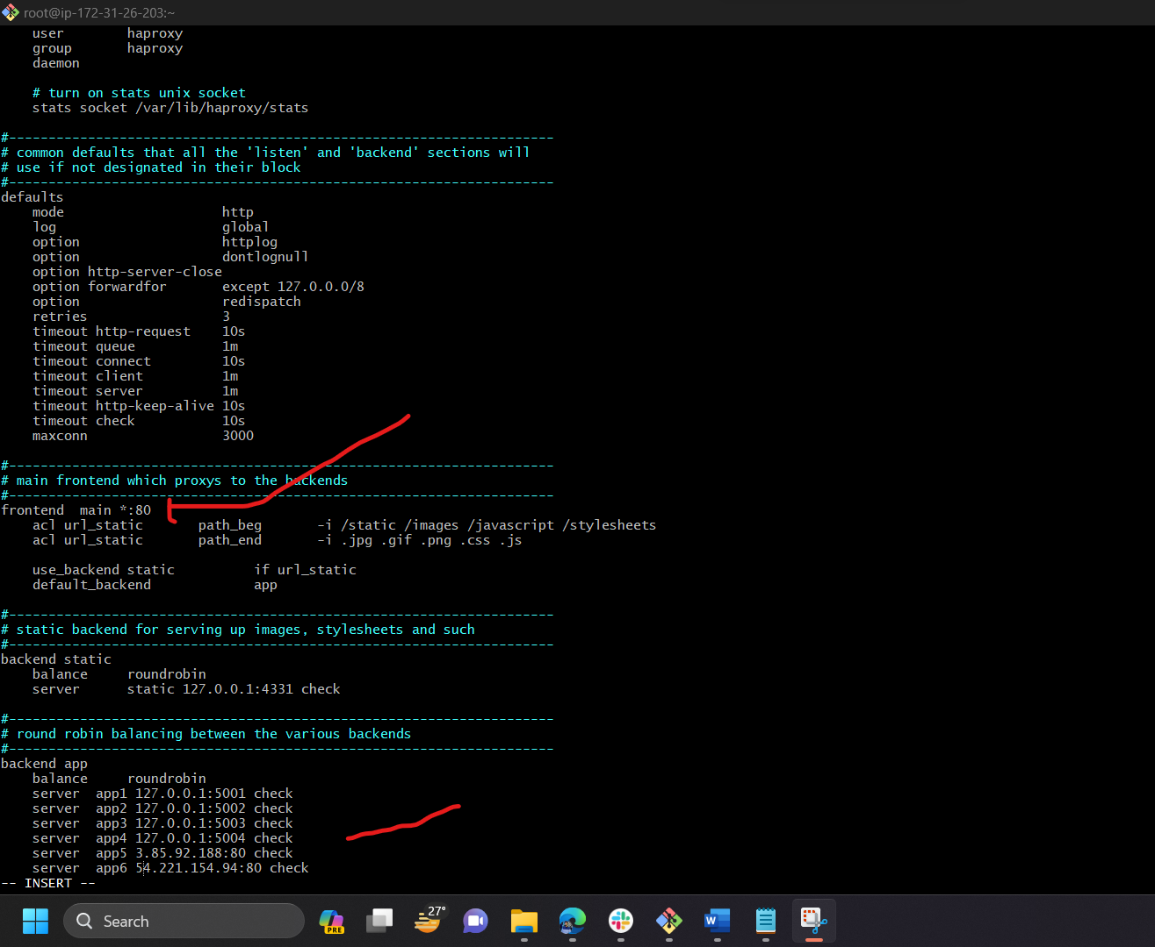

* systemctl enable haproxy
* systemctl start haproxy
* systemctl status haproxy

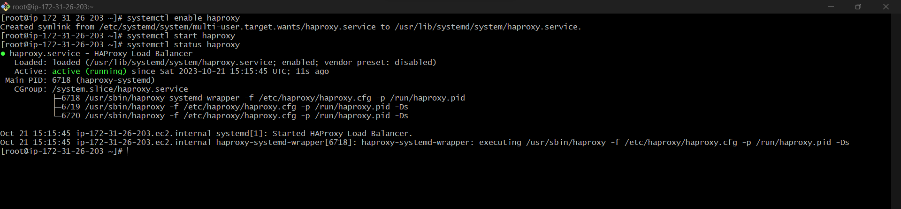

* now browse with HA-Proxy-Server PublicIP:80 it will distribute load to Server-1, Server-2

**Now task started screen shot below**

Created 3 instances name as server1, server2,ha-proxy-server, I have user same key for this three

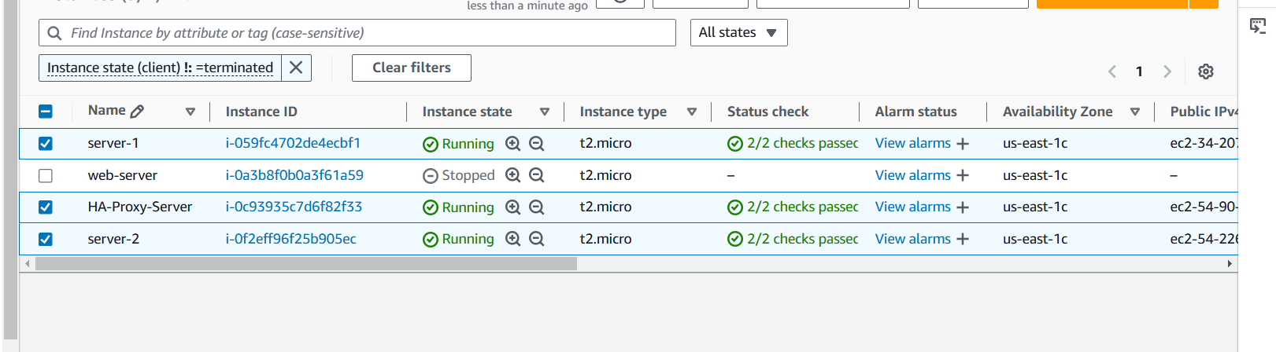

Connecting server/instance/machine to this 3 servers(server1,server2 and proxy server)

This steps for server 1 where we installing httpd and server2 nginx

**Server-1**

**Note: after creating server make sure you have added in security group that all ports allowd**

Go to security click security groups then

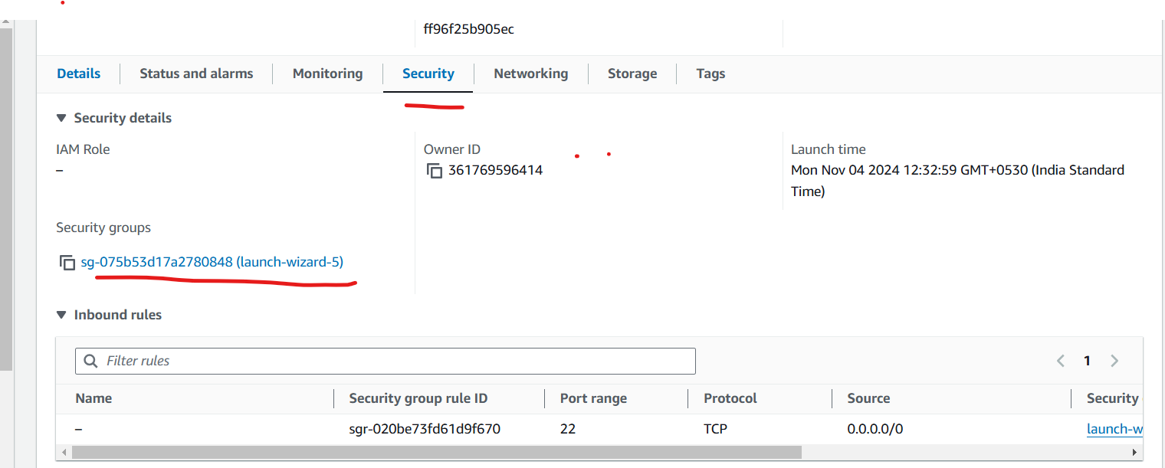

click edit bound select all traffic and anywhereipv3 then save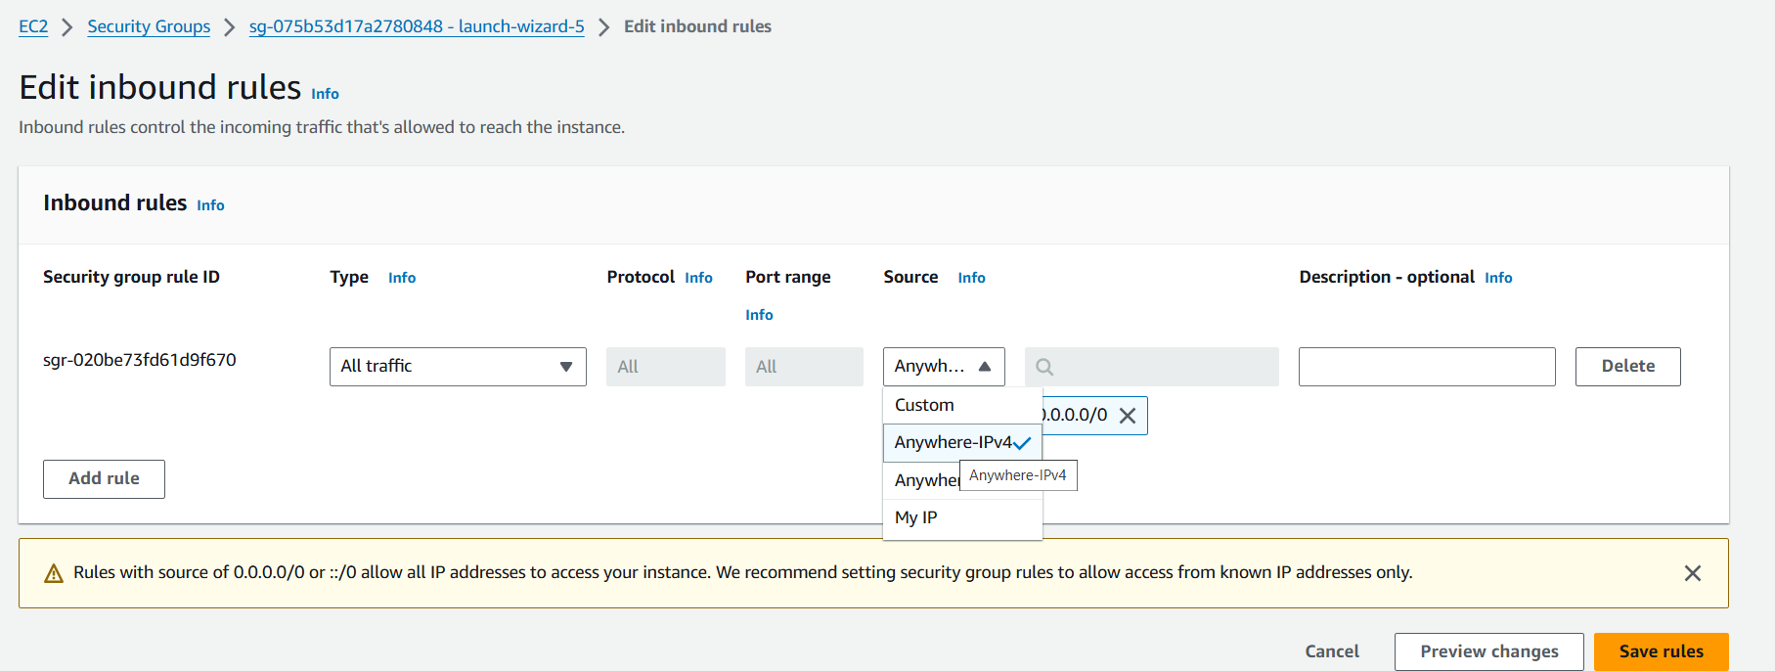

Change to route user so we did not face any permission issue

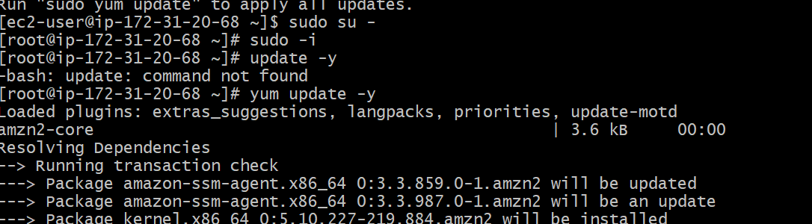

Update packages

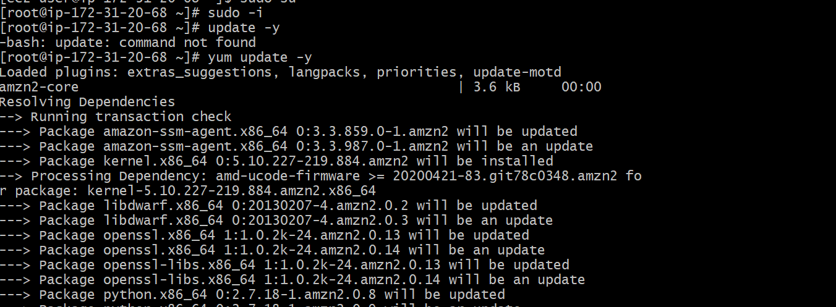

Check package

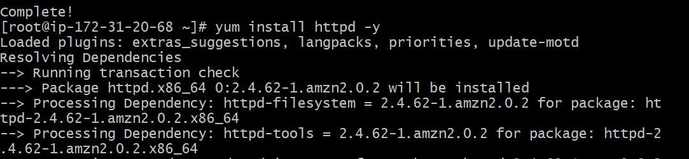

Install httpd package in server1



Go to Vi /etc/hosts

But here I followed some deep commands to check directories and understand

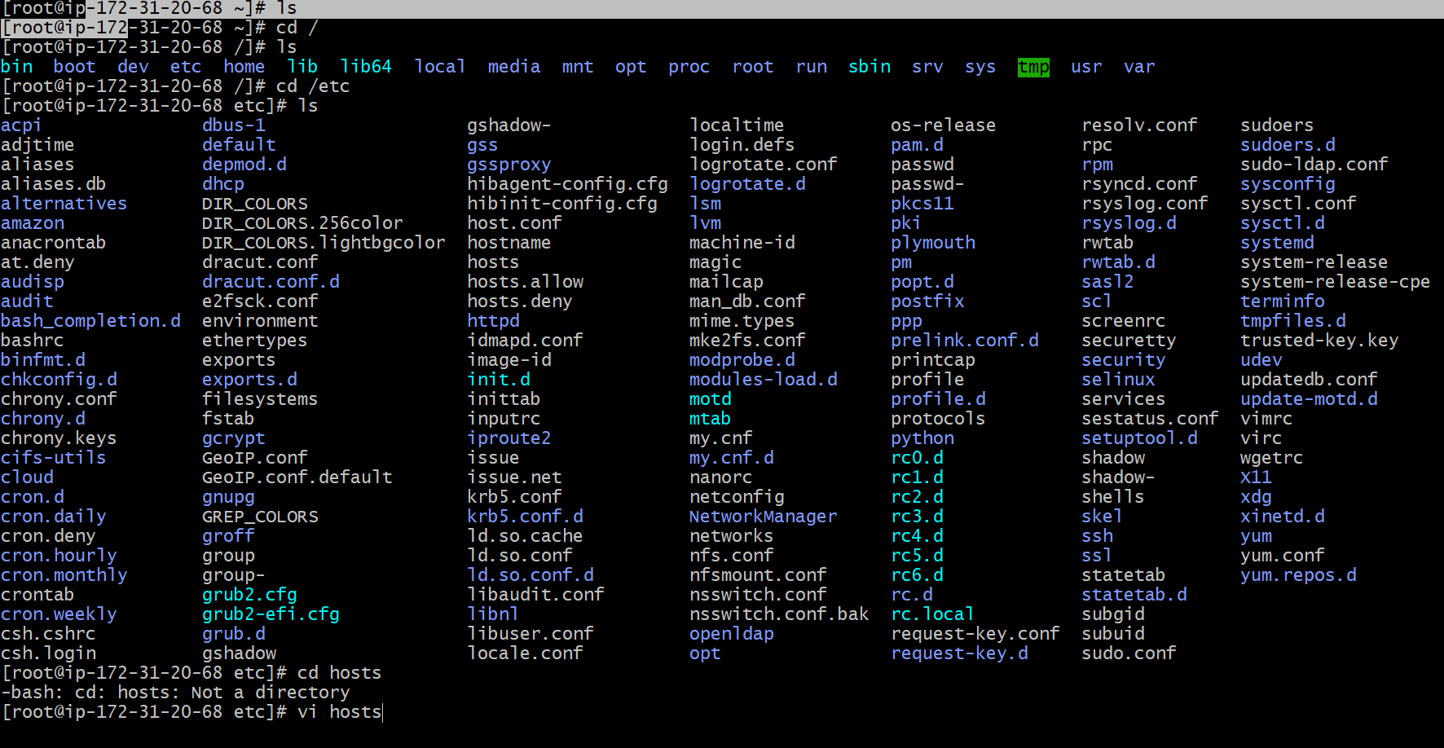

Afte adding load balancer in server-1, this load balancer ip address belongs to **HA Proxy Server**



Ping load balancer



Start and check status and run on Public IP address:80 it will work

* systemctl start httpd
* systemctl status httpd

http://34.207.117.18:80

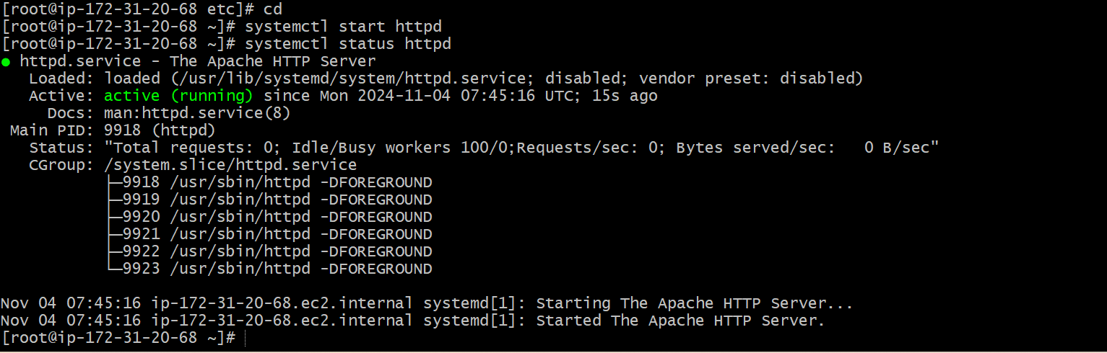

Public IP address:80 it will work

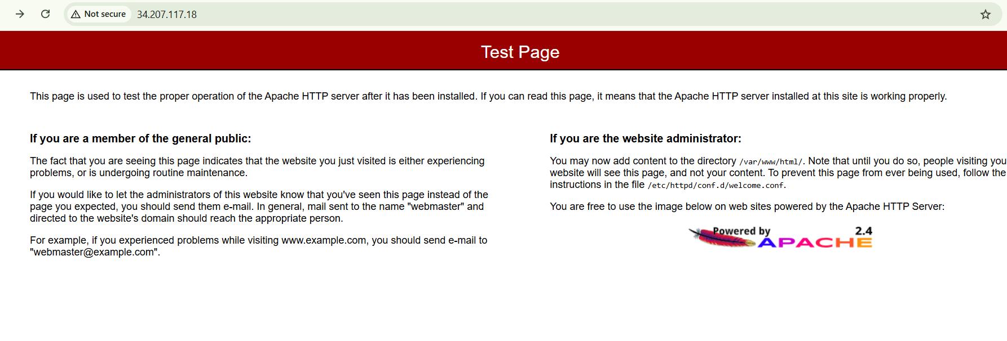

**Server-2(thiss some SS are related to server-1 please check server-2 SS)**

**Note: after creating server make sure you have added in security group that all ports allowd**

Go to security click security groups then



click edit bound select all traffic and anywhereipv3 then save****

Change to route user so we did not face any permission issue



Update packages



Check package



Install nginx package in server2

* yum install nginx -y ==>if not works use below command
* sudo amazon-linux-extras install nginx1 -y

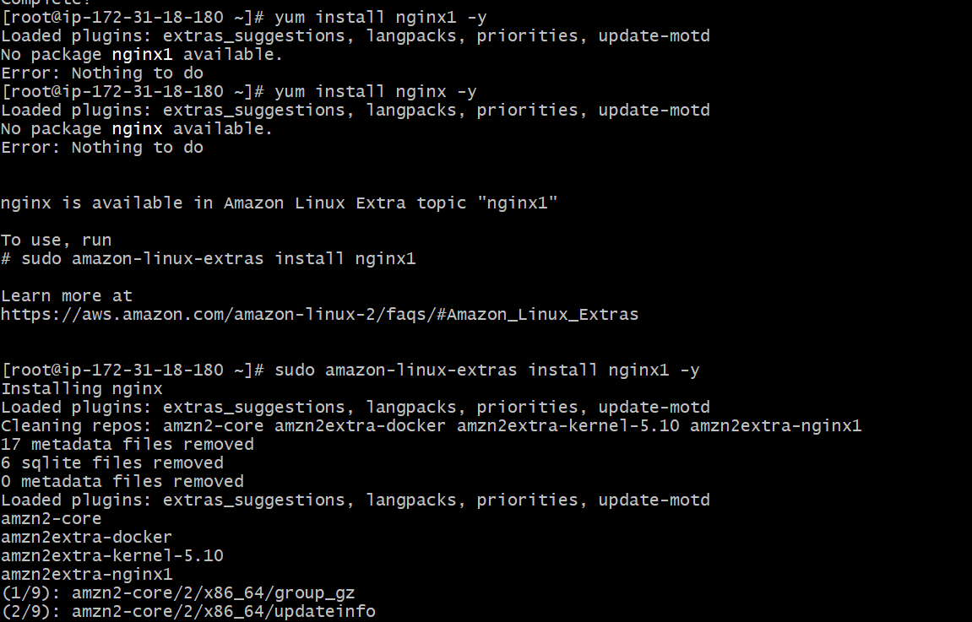

* vi /etc/hosts
* Add HA-Proxy-Server Pubic IP Address



Afte adding load balancer in server-2, this load balancer ip address belongs to **HA Proxy Server**



Ping load balancer

Start and check status and run on Public IP address:80 it will work

* systemctl start httpd
* systemctl status httpd

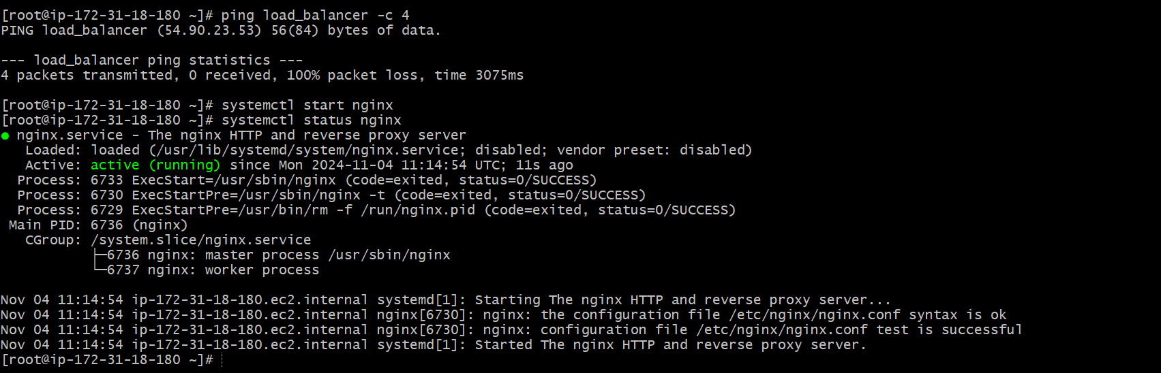

http:// 54.226.200.191:80

Public IP address:80 it will work



**HA-Proxy-Server - 3**

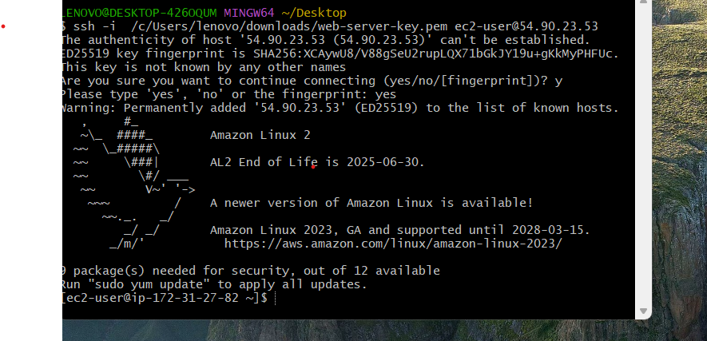

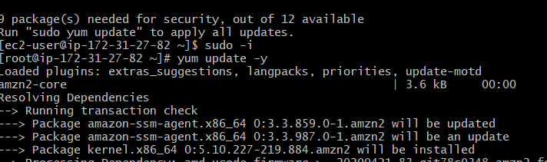

* yum install haproxy -y

install h proxy

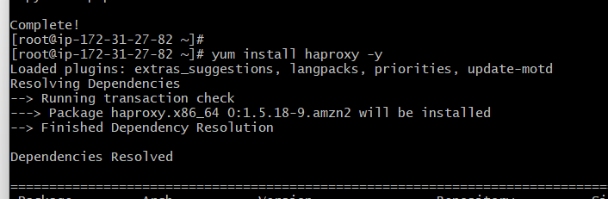

* vi /etc/hosts
* Add Server-1, Server-2 Public IP’s

Add server- 1 and server-2 ip addreses belwo

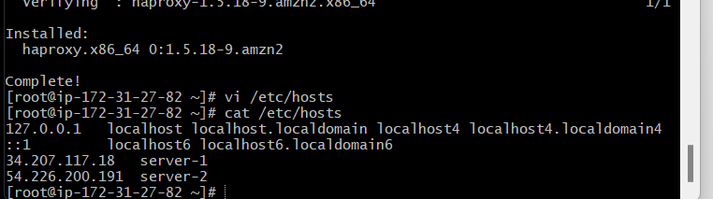

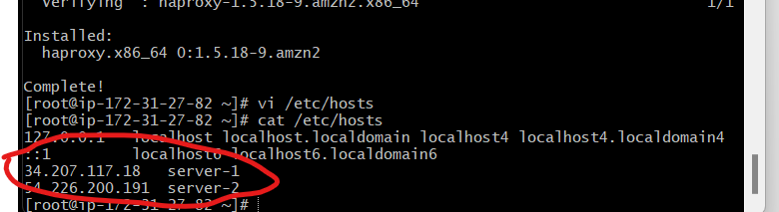

* vi /etc/haproxy/haproxy.cfg
* Add Server-1, Server-2 public IP’s

Here also add ip address

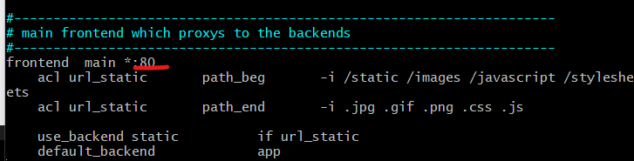

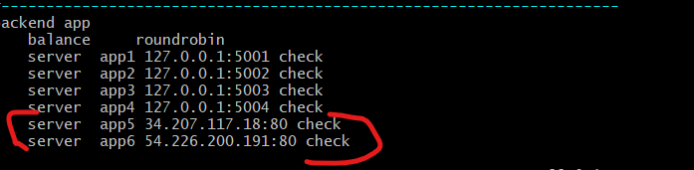

Save then run

* systemctl enable haproxy
* systemctl start haproxy
* systemctl status haproxy

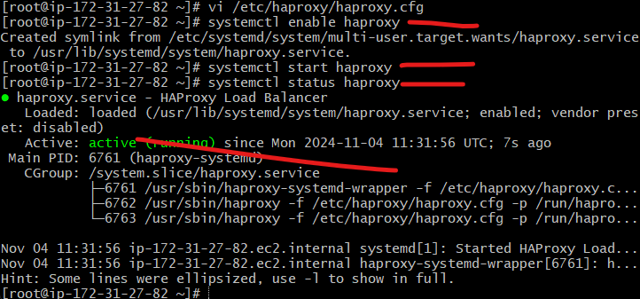

* now browse with HA-Proxy-Server PublicIP:80 it will distribute load to Server-1, Server-2

first laod it will come httpd or apache and second nginx

